ShelterBox Update June 2021
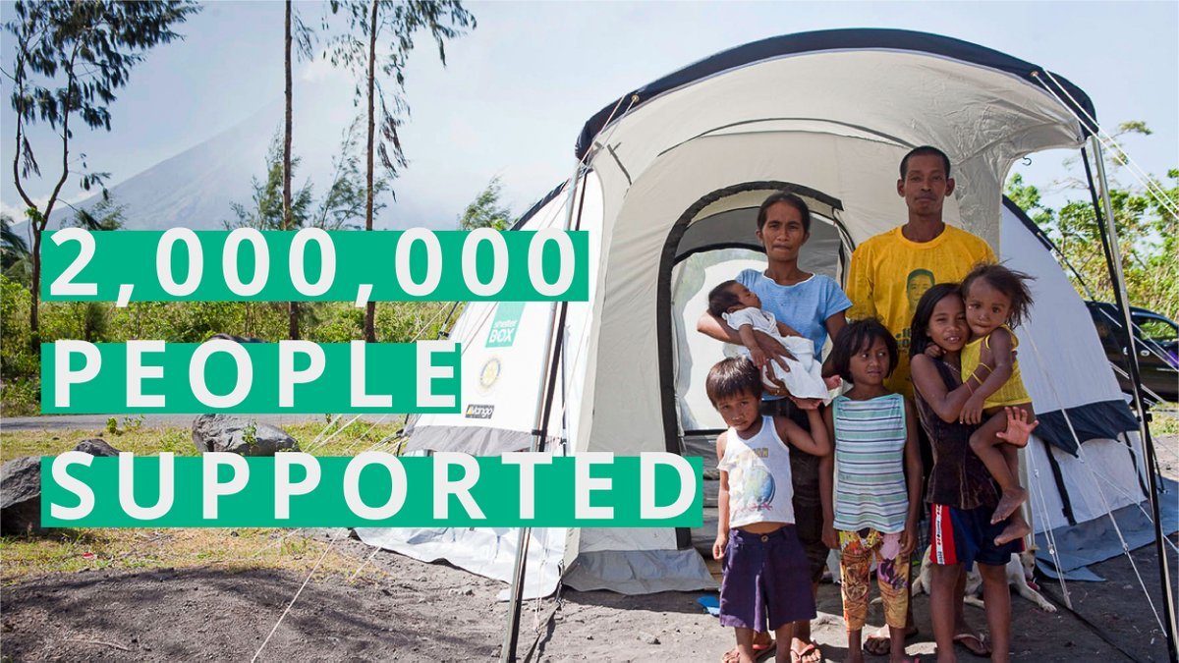
You’ve helped two million people!

Thanks to your compassion and dedication to humanitarian values, together with Rotary we have now supported 2 million people in 98 countries around the world with emergency shelter.

While it took 15 years to help 1 million people, you have helped us reach our second million in the space of just 5.5 years. That’s two million people who have been able to recover after disaster and conflict, all thanks to YOU!

20 years ago ShelterBox began as a millennial project at the Rotary Club of Helston-Lizard in the UK. It is only because of your support, and the support of Rotarians and Rotary Clubs around the world, that we’ve been able to grow into the global organization we are today. Thank you for ensuring no family is without shelter after disaster.

Each year more and more families lose their homes to disaster or conflict. In 2019 alone 104 million people lost their homes.

Together, we are working to ensure no family is without shelter. But we can’t do it alone. We rely on our global partnership with Rotary International to get aid to the families who need it the most. And we rely on Rotarians like you to help us get it there. Join us today by making a donation or by getting your club involved. Your support of ShelterBox Canada means more families have a place to call home. More families have shelter, water, and the tools they need to rebuild their lives. Find out more: https://www.shelterboxcanada.org/2million/

