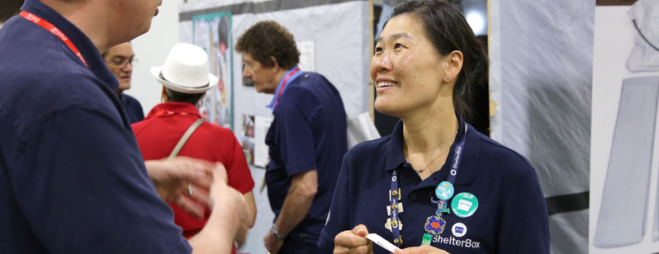

ShelterBox Update
April 2021

SHELTERBOX: Volunteer to put the Partnership into Action
At ShelterBox, we are passionate in ensuring that no family goes without shelter after a disaster. We are proud to be project partners with Rotary International. By working with Rotary, we can collaborate and combine resources to support more communities in desperate need of shelter. Rotarians and Rotary groups across the support us in a variety of ways, from raising funds to providing support on the ground during our responses. This allows us to cross boundaries and work together to reach the most remote communities, and ensure no family is left without shelter after a disaster.

“With a global pandemic, environmental and sustainability challenges, a world refugee crisis and global inequalities, the world needs Rotary and ShelterBox now more than ever.”
Holger Knaack, Rotary International President 2020/21

At ShelterBox, we are so grateful for the continual support of Rotarians across the country. Our Rotary Club Champion volunteer role is exclusively for Rotarians to put the partnership into action. As a Rotary Club Champion, you will help share our message to their clubs and attract new members to support ShelterBox through raising awareness of the tangible impact of ShelterBox’s work around the world. If you are a Rotarian and share our passion to ensure no family is without shelter after a disaster, you should become a Club Champion!

“I have had the privilege of working and living in many parts of the world where natural disasters occur routinely and I have seen the need for help and support required from others. And being a Rotarian, volunteering with ShelterBox Canada provides me with a great opportunity to provide some of that help and support that is required.”
Stephen Beaufoy (Halifax, NS), Rotary Club Champion, ShelterBox Canada

As a Rotary Club Champion you share our passion for ensuring no family is without shelter and share that message within your own Rotary or Rotraract Club. Club Champions aim to deliver increased awareness about ShelterBox within their Club and act as the main point-of-contact between the Club and ShelterBox Canada.

Together, ShelterBox and Rotary are making an impact and you play a critical part of our movement. Every volunteer is instrumental in providing shelter for families after disaster. With whatever skills, knowledge, or spare time, all we need is your passion! With your help, we will be able to reach more families and rebuild their lives. Your help will make a difference in the world of disaster and have a lasting impact on families.

If you would like to learn more about how to become a Rotary Club Champion or know someone who would be a good Club Champion, visit: https://www.shelterboxcanada.org/volunteer/clubchampion/

