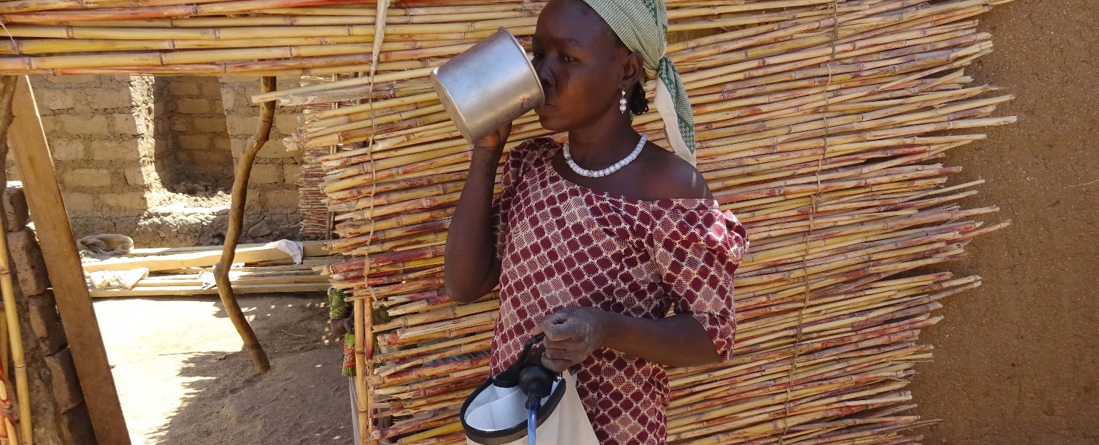
ShelterBox Update April 2021
Water, just like shelter, is a human right.
Whoever you are, wherever you are – you are entitled to clean, safe water. But today, billions of people around the world do not have access to clean and safe water. According to WHO/UNICEF, 2.1 billion people lack access to safely managed drinking water services.

When disasters hit, it forces families out of the homes, making it difficult to access clean drinking water. Disasters cause a huge amount of damage and destruction. Water hand pumps break, and local water sources get filled up with debris, dirt, or chemicals, making it unsafe to drink.

When families are unable to access clean water, water filters can help produce safe drinking water. ShelterBox distributes water filters to families which can turn up to 1,000 litres of unsafe water into clean, safe, drinkable water. These water filters can remove viruses, bacteria, pathogens, chemical, heavy metals, and fecal matter that can be found in contaminated water.

Meet Maïramu. Maïramu and her family of 7 became displaced after their village in Nigeria was attacked by Boko Haram. Like many refugees, the most difficult problem that Maïramu faces daily is access to safe drinking water. “We started to get sick. After a while, I noticed that my children and I were having frequent stomach aches and diarrhea. I realized it was caused by the water.”

After receiving a ShelterBox water filter, Maïramu and her family no longer suffer from sickness and diarrhea. “Thanks to the filter, I can assure you that our problems concerning water are no longer related to sickness, but to distance, because we still have to travel a long way to collect it. Today, we drink water without fear.”

Having access to clean water reduces the risk of illness caused by bacteria and other pathogens found in dirty water. By providing families with water containers and water filters, we can make safe drinking water one less thing to worry about. To learn more about how you can support families with clean water after disasters, visit: https://www.shelterboxcanada.org/world-water-day-provide-clean-water/

