ShelterBox Update
November 2020
UPDATE FROM THE FIELD: Nongoma in Burkina Faso

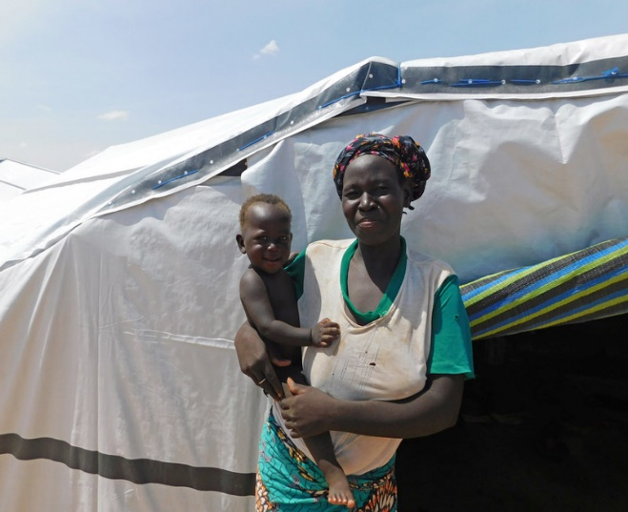
“There were a few incidents in the neighbouring village earlier on in the year, so we thought we were spared. Until the armed groups arrived in our village. It was at the market that they started shooting, and my husband who was there died. We were forced to flee without taking anything with us.”
34-year-old Nongoma is a mother of seven living in Burkina Faso, West Africa. Currently, her and her children are living in a camp for internally displaced people, after fleeing for their lives after attacks on their village. That day, Nongoma’s life was changed forever.
Nongoma and her husband used to be agricultural producers but now she cannot work and relies on humanitarian assistance like yours to keep her and her children safe. “I was lucky enough to be housed here next to people from the same village and we continue to have very good relations.”
Although she is safer now than she was in her village, Nongoma is worried that her children are not getting an education, like they were before the attacks. “Four of my children were in school but when we arrived here, it was only the oldest child that I was able to re-enroll in college. The other children missed school this year because I did not have enough money.”
Nongoma and her family collected ShelterBox aid including tarpaulin, kitchen sets, sleeping mats, mosquito nets and solar lamps. “With the help of ShelterBox with new, beautiful tarpaulins, we are now well housed, and I am very satisfied.”
For Nongoma and her children, the future is very uncertain. But for now, thanks to your support, she feels safe. “Return is very scary and haunts me. When I think of the village, the image of my husband’s murder comes to mind. I have a shelter that allows me to stay for a while. When everything calms down, we will see.”
Peacebuilding is one of Rotary's areas of focus, but when peacebuilding fails, the people it displaces become in need of much more than just the end of violence. You may think of ShelterBox as only responding to natural disasters, but we work in many crises of conflict driven displacement as well.
Armed violent extremist attacks in Burkina Faso, West Africa have caused almost 1 million people to lose their homes and is quickly becoming one of the world’s fastest growing humanitarian disasters. Government forces and militias are trying to combat this violence, but this has led to even more families being uprooted. ShelterBox is supporting families like Nongoma’s and working with partners on the ground to ensure families receive the shelter they need and are able to protect themselves from the spread of COVID-19.
Learn more about the ShelterBox Rotary partnership and how you can get involved at: ShelterBoxCanada.org/Actiontoolkit
--------------------------------------------------------------------------------------------------------------------------

