ShelterBox Update
December 2020
20 YEARS OF GRATITUDE: Home for the Holidays
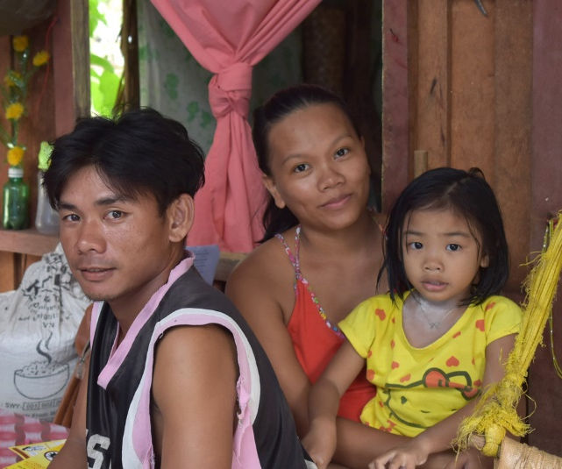
As the calendar year comes to a close and we reach the half-way point of the Rotary year, families all over the world are gathering in new ways to find gratefulness in being together, however that may look. Thank to our supporters in 2020, ShelterBox has been able to ensure that over 25,000 families have a home for the holidays. Home is the center of all that we do at ShelterBox, the same way as home is central to lives, families, and communities.
“For Filipinos, home – or ‘bahay’ as we call it – really is where the heart is. It’s the centre of our family life, our social life and very often our working life too. At Christmas especially, being able to get together in our own homes means everything to us.”
– Rose Placencia, ShelterBox Operations Philippines
The pandemic did not stop natural disasters from affecting the Philippines this year. Most recently a series of typhoons, including Typhoon Goni, the most powerful storm since 2013’s Typhoon Haiyan, devastated many communities in the region. In 2020, before Typhoon Goni stuck, ShelterBox had responded twice to the Philippines, in response to Volcano Talal and Typhoon Vongfong. As we deploy in response to this new wave of tropical storm destruction, Alejandro and his family are just one of those recovering from Typhoon Vongong who now has a home for the holidays.
Typhoon Vongfong (known locally as Ambo) devastated communities across Eastern Samar in the Philippines earlier this year. The destruction caused by the typhoon and the torrential rain that it brought with it affected nearly half a million people.
26-year-old Alejandro lives with his 25-year-old wife Jennifer and their 3-year-old child Keth in the Eastern Samar region. They have lived in this region for four years, but unexpectedly, Typhoon Vongfong destroyed their home. ShelterBox was able to support Alejandro and his family with materials to rebuild.
We asked Alejandro what items that he received were most helpful to his self-recovery, ‘the tarpaulin and the solar light. We used it as roof and wall. The solar light is a very big help because we only have one bulb for the entire house, It’s not dark anymore. We feel safe because we are covered with these tarps already, we have our privacy now. Our daughter is smiling more often now because according to her we have a new house.’
Support from Rotary Clubs and Rotarians all over the world make supporting families like Alejandro’s possible. This Holiday season we are so grateful for your support knowing that because of you, more families can light up their own homes for the Holidays.
Join ShelterBox Canada Response Team Members and Rotarian staff December 11 via Zoom to ask your questions and learn more about our work in the Philippines. Register here:
--------------------------------------------------------------------------------------------------------------------------

