ShelterBox Update
October 2020
20 YEARS OF PREPARDNESS: Hurricane Season is Here
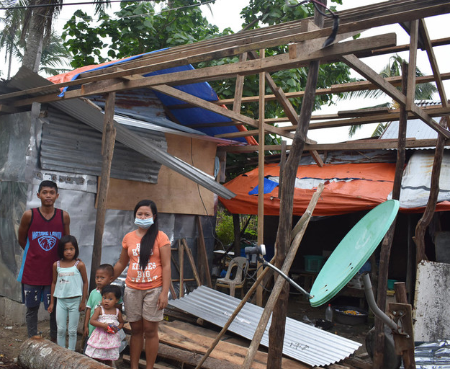
2020 has been a year like no other. While coronavirus continues to spread around the world, extreme weather events are now lurking as well.
This year’s Atlantic Basin hurricane season is more active than usual. The NOAA (National Oceanic and Atmospheric Administration) has already recorded more powerful named storms than average since the start of the season.
But what does an extremely active hurricane season look like in practice? The 2020 hurricane season, which runs from June to November, is already off to a flying start. By early August, there have already been a record-high of nine named storms, including two hurricanes. The NOAA is forecasting 19 to 25 named storms, with between 7 and 11 hurricanes, and 3 to 6 major hurricanes. We can remember how devastating the hurricane season was in 2017, particularly in the Caribbean. Rotary Clubs helped us prepare and we were able to respond quickly after Hurricanes Irma and Maria swept through the area, leaving significant destruction behind.

Thanks to our global network of supporters like you, we’re always ready and on standby, monitoring weather events using a number of alert systems.

There are always challenges when responding to devastating hurricanes. This year, however, the challenges are very different. The coronavirus pandemic means that it will be more challenging for response teams to travel to hurricane-hit countries. But our links with local partners and Rotary worldwide means we can provide aid in new ways that keep families safe. This combined with our storage of pre-positioned aid in strategic locations globally, means we are still able to get shelter to families who are in a vulnerable position – no matter what.

Recently, ShelterBox has been able to support families in the Philippines who are recovering from Typhoon Vongfong. The only difference between typhoons hurricanes is the location where they form. Heavy rains and wind-speeds of up to 165km/h caused extensive damage and destroyed thousands of homes across the islands. But thanks to Rotary Clubs and Rotarians around the world, ShelterBox was prepared to help!

Aid was delivered to 1,000 families in the Oras and Arteche municipalities, regions where no other shelter support was being provided. Families, such as Rodante and Nalcie’s in the photo above, have been given the tools they need to start rebuilding their homes, and move out of congested evacuation centres, providing the ability to isolate as COVID-19 still spreads.
ShelterBox responds to Hurricanes, Cyclones, and Typhoons all over the world, and being prepared for when they
strike is the first step. Challenge yourself and those in your club to help us prepare for our hurricane responses before they strike. Learn more at: ShelterBoxCanada.org/challenge

--------------------------------------------------------------------------------------------------------------------------

