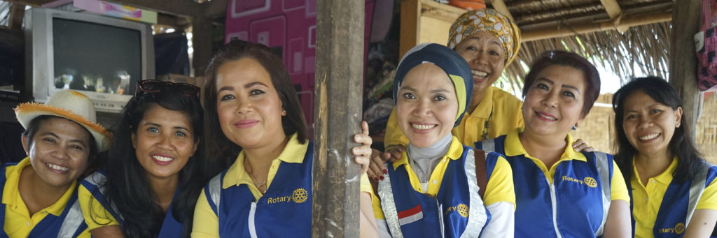20 YEARS OF SHELTERBOX: 20 Years of Partnership
ShelterBox Update
August 2020
From the founding members in Helston-Lizard, to our partnership with Rotary International, to the individual Rotarians who passionately support us both personally and through their clubs – the passion, trust, and dedication from Rotarians all around the world, is an important part of ShelterBox’s past, and our future.

In 2000, the idea for ShelterBox was thought up by the Rotary Club of Helston-Lizard in Cornwall, United Kingdom, when Rotary encouraged members to come up with projects to mark the Millennium. The idea was sparked by watching the news and wanting to do more after seeing that people seemed to be left with nothing after disaster. ShelterBox was launched by the club with the initial hope to help 8 to 10 families a year, with each box containing a family-sized tent, sleeping bags, water purifying tablets, tools, and pots and pans.

In the first year, this group of passionate volunteers took the idea and developed it into something more. They investigated the emergency items people need and worked to understand transport and logistics. They spoke to manufacturers and found a sturdy box. They visited the Rotary International Conference to drum up support and wide-spread passion. That first year, Rotary Clubs alone donated $150,000. The faith shown by the Rotary community led to the first response supporting families affected by the 2001 earthquake in Gujarat, India.

As ShelterBox grew, so did Rotary’s support. In 2012 ShelterBox became recognized as Rotary International’s official project partner in disaster relief. Around 1,000 Rotary members are involved in ShelterBox as volunteers, staff or response team members. Clubs worldwide offer valuable, practical on the ground assistance to help while clubs here in Canada tirelessly raise funds and awareness to help more families after disaster. ShelterBox also has fundraising teams in 15 countries around the world – all founded by Rotary members.

We have continued to evolve and innovate over the past 20 years, but one thing that has never changed is that everything we do is guided by the same goal: helping families rebuild after disaster.
To make sure we do that as effectively as possible, we constantly question what we do. We explore what we could do differently. We ask ourselves how we could be better. We put innovation at the heart of our work, always searching for ways to improve. It’s why we no longer provide aid only in boxes, after families told us they sometimes need larger emergency items that don’t fit in our ShelterBoxes. It’s why we worked with the company that makes our solar-powered lights, after families told us the batteries used to run out too quickly.
Today in 2020, the need for emergency shelter is more urgent than ever, with more than 88 million people living without shelter after disaster or in times of conflict. We must do more. And thanks to the support of Rotarians around the world, we are as determined as our founding Helston-Lizard Rotary members to do just that.
Looking for speakers this Rotary year? We would love to tell your club even more about ShelterBox and the impact Rotarians make. Request a speaker: https://www.shelterboxcanada.org/actiontoolkit/request-a-speaker/
--------------------------------------------------------------------------------------------------------------------------

