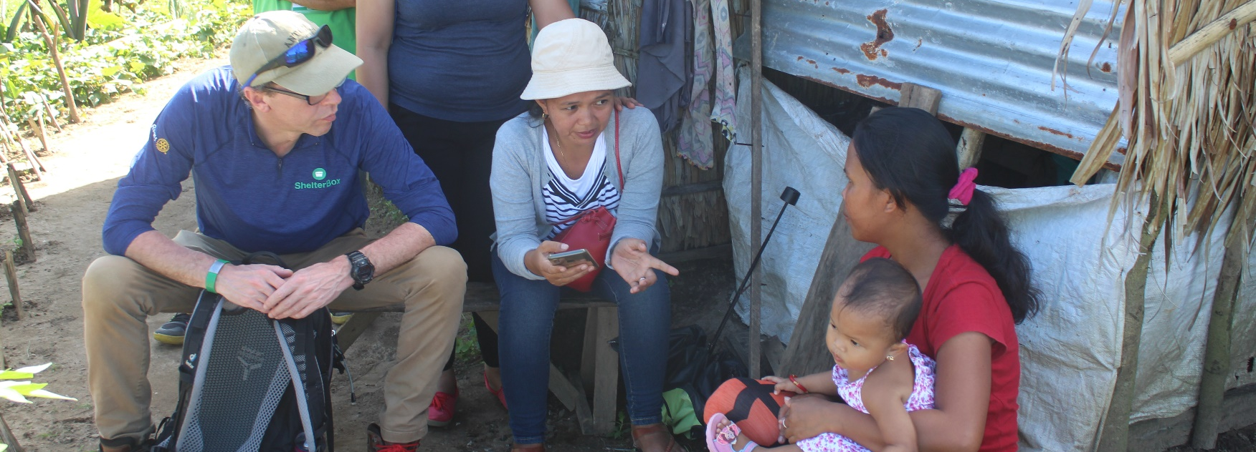
ShelterBox Update
July 2020
20 YEARS OF LEADERSHIP: ShelterBox Remains a Leader in Emergency Shelter

As Rotary clubs around the world change leadership for the new Rotary year, ShelterBox remains a leader in disaster relief all over the world. Each year, Rotary helps us to go further, support more people, and access areas that would otherwise be impossible to reach.

ShelterBox is recognized in the humanitarian sector for our world-leading technical and specialized expertise in emergency shelter. Our staff and volunteers have specialist skills that many larger organizations don’t have. We are valued for being flexible enough to work side by side with partners, we provide training not only for the communities we support but also for local partners who provide longer-term support when we are no longer there.

At ShelterBox we listen to the families that we work with, ensuring they receive what they need for their self-recovery and ensuring that the community and their leaders remain at the center of the responses. Leading by listening, we are constantly adapting to the needs of the communities that we work with. COVID-19 has made clear our ability to lead the adaptation of the disaster relief sector, such as in The Philippines. ShelterBox Operations Philippines, one of our permanent operations offices, was approached by a local hospital in Cebu asking for support to make additional shelters for triage and testing areas. Their disaster, this time was COVID. Due to our reliable response in many areas in The Philippines, we are seen by the local community as leaders in shelter aid. We were able to respond, providing tarps and other shelter materials to meet this hospital’s needs.

Rotary is a leader in the international community as well, making change and opening opportunities. As local Rotary Clubs partner with other clubs around the world to execute life-changing projects, often too does ShelterBox. Local partners are also incredibly important to the lasting impact shelter can make. With COVID-19, travel restrictions have limited the ease of international travel. We have adapted and are still able to reach families that we are committed to by leading responses with local partners. This means that we are still able to reach families with shelter aid, but also work to adapt these responses to fit the communities even better.

Strong leadership is important to any Rotary club as it is to us at ShelterBox. Each ShelterBox Response Team Member, who is on the ground in our deployments, is trained in how to be a leader in high stake situations that they may face. Using what we teach them, we have created the ShelterBox Training Centre, specifically for Rotary clubs to grow through leading together, building stronger clubs in our communities.

We always welcome more leaders to join us. Become a Club Champion and lead the awareness of ShelterBox in your community and district. Lead fundraisers with your club or your community to ensure that more families are able to receive the shelter that they need after disaster or conflict. Leaders always continue to brush up on their skills. Access to the Training Centre as well as numerous other resources in our specially designed Action Tool Kit at: shelterboxcanada.org/actiontoolkit.

