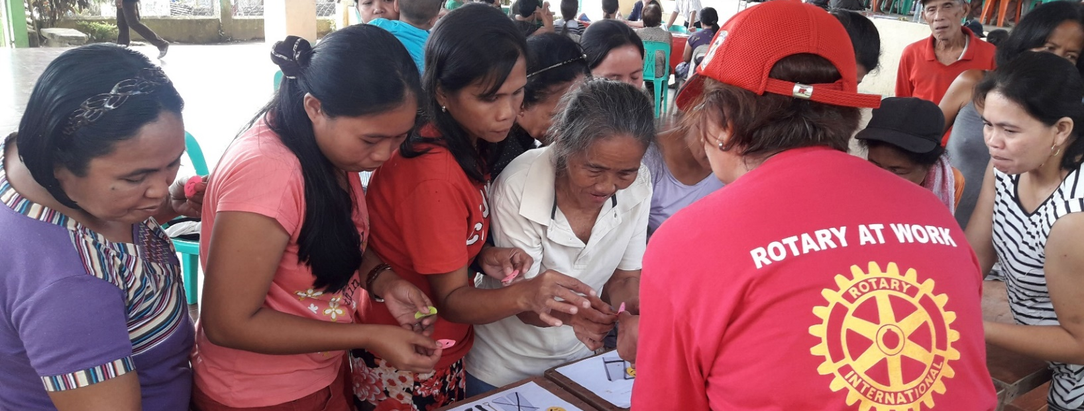
ShelterBox Update
June 2020
20 YEARS OF PARTNERSHIP: Working Together in The Philippines

Rotary is at the heart of all that we do at ShelterBox. Beginning as a Rotary Club project 20 years ago, our partnership with Rotary International has grown over the years, becoming their official Project Partners in Disaster Relief in 2012. By working together, we are ensuring that no family is left without shelter after disaster. Not only do Rotary and Rotaract clubs around the world support ShelterBox financially, but on many of ShelterBox’s deployments local Rotarians, Rotaractors, and Response Teams work closely together at an operational level. Rotarians often have great connections with communities and authorities that can help response teams understand the situation and respond better together.

One of the clear marks of this partnership is the work that we do in The Philippines. ShelterBox has responded in the Philippines more frequently than any other country – an average of nearly twice a year between 2004 and 2019. In the past we have used our usual model, sending teams of international volunteers to import aid.

This worked well until Typhoon Haiyan hit in 2013. After this disaster, The Philippines has become much more difficult for international charities to work in, making it considerably more challenging for ShelterBox to import the vital aid families need. As a response to these new challenges, ShelterBox Operations Philippines, a locally registered ShelterBox office was set up in 2018 to connect local Rotarian Coordinators and have aid on stand-by in country. This way, when a disaster hits in the Philippines, our response can begin almost immediately.

Our presence in The Philippines both in aid deployments, as well as the permanent presence of ShelterBox Operations Philippines, means that we are well known in the region as a leader in disaster relief. In April, we were approached by a public hospital in Cebu, requesting shelter assistance as emergency triage areas for the hospital’s COVID-19 response. We were able to provide materials and expertise to assist the hospital in their needs, strengthening their ability to respond to the crisis.

With adapting our current responses to COVID-19, we recognize that natural disasters are still inevitable. We are monitoring the impact of tropical storm Vongfong, which is the first typhoon of the season in the West Pacific. Typhoon season is far from over in The Philippines, but with assistance from Rotary in the region and all over the world we are able to help more families recover year after year.

Disaster recovery is a process. When ShelterBox and Rotary work together after disasters, having ShelterBox’s technical expertise and Rotary’s community connections and knowledge side by side means that families are given the best tools and support that they need through each step of the process to recover and rebuild.

Resources to support the Rotary ShelterBox partnership have been designed specifically for Rotarians! Learn more at: shelterboxcanada.org/actiontoolkit

