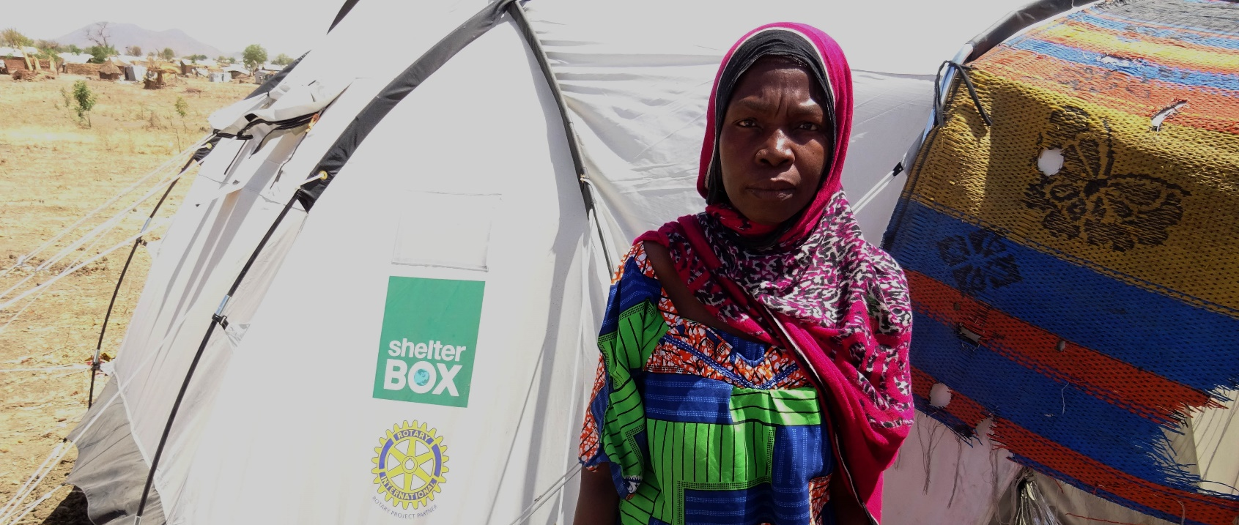THE DISASTER OF CONFLICT: Meet Falmata
ShelterBox Update
May 2020

32-year-old Falmata is from Banki in Nigeria. She is a single mother and lives with her four children in an emergency shelter at Minawao Camp, having fled her home to escape violence from Boko Haram. When they arrived in the camp, they stayed in a transit centre with other displaced families. Her first days were very difficult, especially as she had received no news of her husband’s whereabouts. Eventually Falmata received an emergency tent like others at the camp: “I was very satisfied when I got a tent”, she explained.

Despite regaining a sense of privacy thanks to the tent, provided by ShelterBox and IEDA Relief (ShelterBox’s partner on the ground), the issue of collecting water continued to be a problem. One of her main challenges was to find a way to store water for longer periods:

“I received many items, but the ones that are really important are the water carriers. Having water here (in Minawao) is not easy… But now I have the possibility of storing drinking water for two days”, she explained. “I live much better with them (the water carriers).”

Falmata told the team the water carriers are especially useful when storing drinking water. By using containers to store larger quantities of water, her children don’t have to travel to fetch water every day.

ShelterBox remains the only tent provider in Minawao Camp where over 65,000 displaced people are currently living. Peace building is incredibly important to the quality improvement of life for people all over the world, however when that process fails, thousands of refugees are left behind. At ShelterBox we are committed to aiding those displaced families, like Falmata’s in their journey of self-recovery. If you would like to learn more about how we are adapting our response in Minawao Camp in light of COVID-19 visit us at ShelterBoxCanada.org.

ShelterBox Book Club International

Are you a Book Worm or an aspirational one? ShelterBox has launched their Book Club International and wants you to join them! Each month, ShelterBox teams carefully select a compelling story from around the world for book club members to read.

You can join the ShelterBox Book Club community on Facebook for interactive discussion, Q&A with authors, highlights from response team members and more! Read along at your own pace and join the discussion online. You’ll participate in discussion about the book and what you’ve just read, but you’ll also get to learn more about the people and places inspired by these books. You’ll hear from different authors about different perspectives and experiences. And you’ll receive firsthand stories from ShelterBox members who’ve travelled around the world, visiting these countries to deliver aid.

--------------------------------------------------------------------------------------------------------------------------

