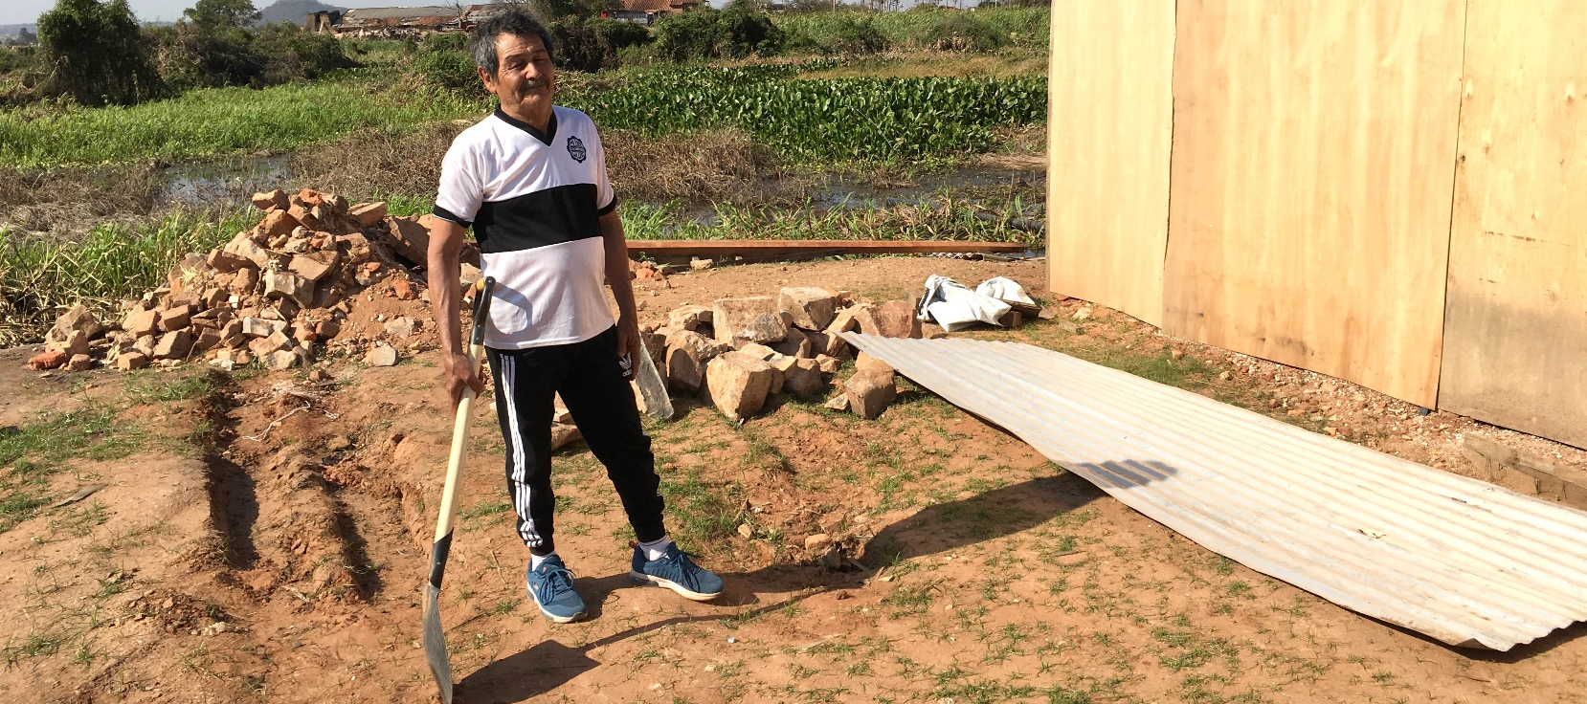
FROM THE FIELD: Impact of ShelterBox aid in Paraguay
ShelterBox Update
September 2019

Cecilio and his family live south east of the Paraguay River. In March 2019 they were forced out of their home when rising water levels flooded their town. They only had one day’s warning to move themselves and all their household possessions to a safer place.

Over the years, Cecilio said the water levels had become more frequent. “The waters rise far quicker than they used to, they used to rise slowly, and people had time to self-evacuate”, he said. Now families have much less warning. The water comes in so fast that they have to take what little they can carry and get out as fast as they can. Cecilio’s family had little warning as the alarms are only raised if the water levels increase in the northern part of the river. They are not always communicated well.

Cecilio said he was pleased to collect the aid items from ShelterBox. He was one of the first to receive them during one of the first distributions in July 2019. When the team met Cecilio to hear his story, he’d had the aid for a little over two weeks. He explained how it was well timed as he could now return home just as the river levels receded. He told the team that aid items from ShelterBox had given him the motivation to return to his original home and begin repairs on his property which was damaged by the floods.

Along with other members of his community, Cecilio received training on how to repair his home. “I paid close attention during the training to ensure that I could make the appropriate repairs to my home, and so that it lasts longer and remains stronger the next time the floods come”, he said.

Cecilio used the hammer and nails to repair his old roof and build the frame for another section of his house. He plans to use the tarpaulins to build the roof and weatherproof the section of the house he was framing. He said his favorite item was the shovel which he has used to level out and heighten the ground for both his and his neighbours properties to be rebuilt on. He has also dug trenches for drainage, and post-holes to support the frame of his building. “It is much better than my previous shovel”, he said. “It is a better quality and is lighter, so it is easier to use”. He continued by saying that he knows the tools and tarps will last because of the quality. Cecilio’s old spade has become rusted from the flooding

Another favourite item of his was the solar light, he uses it every night and charges it in the day, calling it his “sun in the night.”

For more information about ShelterBox and to learn more about where we are responding, visit us at www.shelterboxcanada.org/operations-update

ShelterBox Canada – 159 Jane Street, Office 2, Toronto, ON M6S 3Y8
E: support@shelterboxcanada.org T: 647.352.1930 www.shelterboxcanada.org

ShelterBox and Rotary are official project partners in international disaster relief. ShelterBox is a registered
charity independent of Rotary International and the Rotary Foundation

