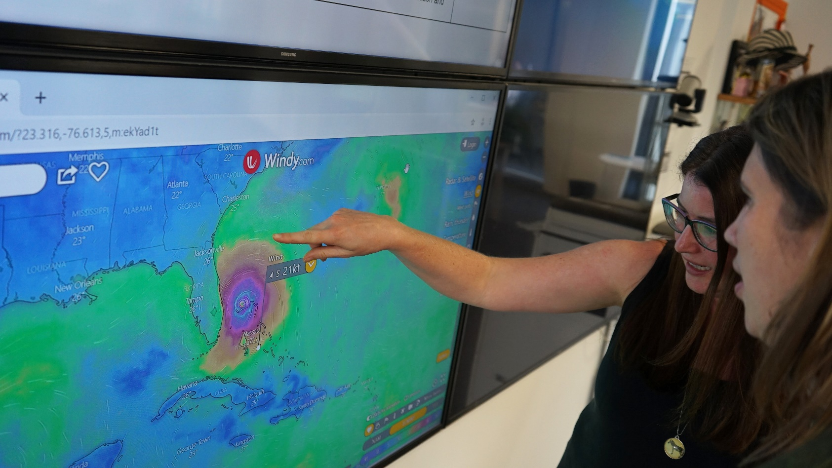**MONITORING EXPLAINED: How does ShelterBox follow storms and their destruction**

**ShelterBox Update**

*October 2019*

At ShelterBox, we are constantly monitoring weather systems and disasters around the world. We work with local partners, including Rotary Clubs and Rotarians to understand the situation on the ground and determine whether or not our aid is needed. But what do we mean by monitoring?

The monitoring phase happens from afar, at ShelterBox headquarters

* Staff watch storms as they form and gather as much information as they can
* As you know, storms are unpredictable and can change direction, grow faster, or quicker than expected so teams are always watching
* As storms approach land, teams begin to evaluate the potential in country impact of storm

When a storm hits land our operations team closely monitor the situation in the country.

* Staff begin to gather as much information about the disaster as possible through a wide variety of sources
* Staff talk to local governments, local partners or contacts in country to understand what they are initially seeing as the storm hits
* ShelterBox reaches out to Rotarians and Rotary Clubs to gather as much localized information about the storms early impacts as possible

Following the storm, we talk to a variety of humanitarian partners and Rotary International, local Rotarians and local Rotary Clubs to help us gather information like:

* How many families have been affected and does the government have resources to support them
* Is ShelterBox aid appropriate for the affected communities
* Has the government asked for help or allowed international aid into the country

After this process, if it looks like our aid may be needed and is appropriate, ShelterBox sends trained teams into an affected country to make a more informed decision about the number of families who require our aid, and which items are most appropriate. You can read more about our complete decision to deploy criteria at [www.shelterboxcanada.org/decision-to-deploy-criteria](http://www.shelterboxcanada.org/decision-to-deploy-criteria)

Your support allows ShelterBox to monitor storms, assess the needs of families in affected countries, and deliver aid to those most vulnerable after disaster. Thank you for helping to ensure that ShelterBox is always prepared.

For more information about ShelterBox and to learn more about where we are responding, visit us at [www.shelterboxcanada.org/operations-update](http://www.shelterboxcanada.org/operations-update)



**ShelterBox Canada – 159 Jane Street, Office 2, Toronto, ON M6S 3Y8**

E: support@shelterboxcanada.org T: 647.352.1930 [www.shelterboxcanada.org](http://www.shelterboxcanada.org)

ShelterBox and Rotary are official project partners in international disaster relief. ShelterBox is a registered

charity independent of Rotary International and the Rotary Foundation