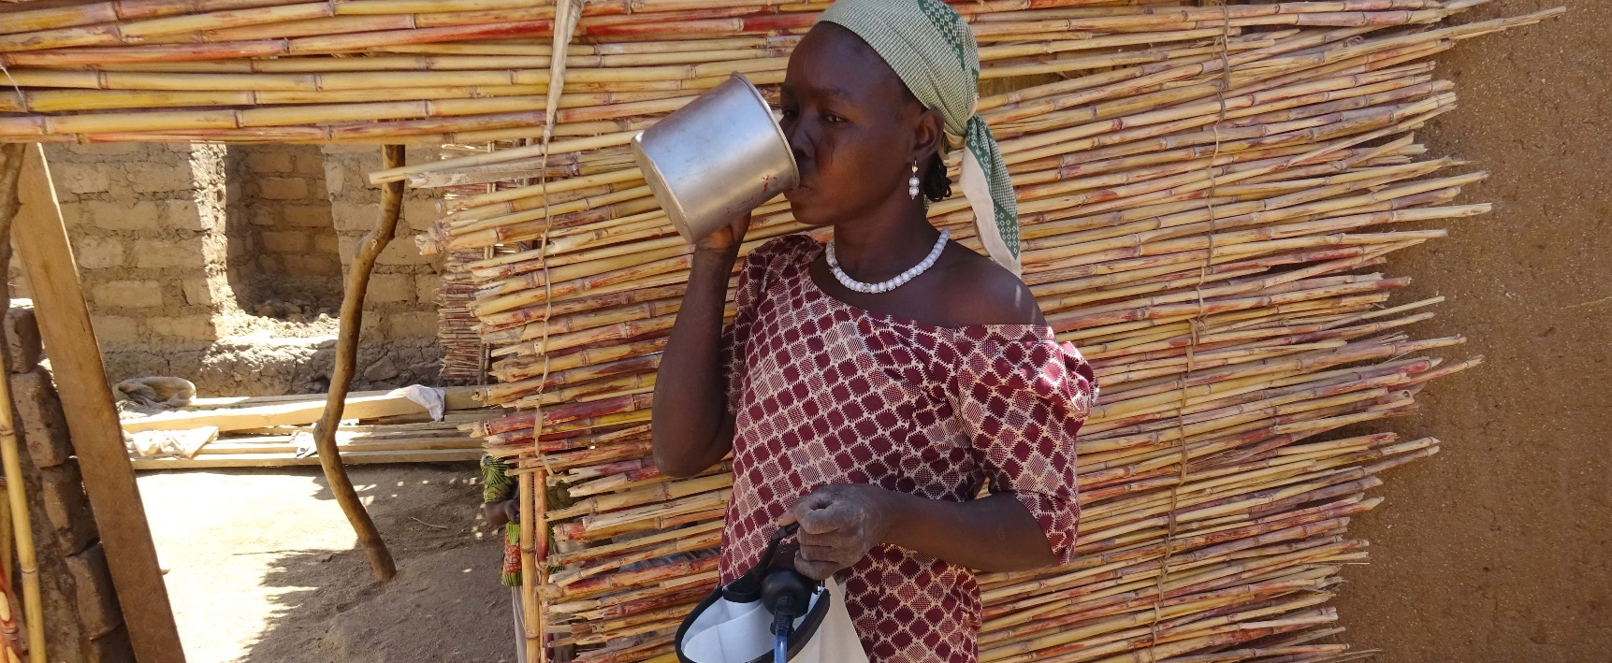20 YEARS OF INNOVATION: Maïramu’s Water Filter
ShelterBox Update
March 2020

This year, ShelterBox is celebrating 20 years of disaster relief! In 2000, the idea for ShelterBox was thought up by the Rotary Club of Helston-Lizard in Cornwall, United Kingdom as a project to mark the Millennium. ShelterBox was launched by the club that same year. The initial hope was to help 8 to 10 families a year by providing emergency shelter and essential items in times of crisis. Since ShelterBox’s first deployment to India in 2003, we have grown to become a respected humanitarian organization, and have supported over 1.5 million people.

In 2012, with Rotary members around the world rallying behind a shared vision, the partnership between ShelterBox and Rotary was formally recognized when ShelterBox became Rotary's official project partner in disaster relief.

Innovation is at the heart of ShelterBox, working with communities to understand what is needed most after a disaster. Over the last 20 years, the water purification system is proof of this innovation. This water and sanitation month we want to introduce you to Maïramu.

33-year-old Maïramu lives in Minawao Camp in Cameroon with her seven children. Originally from Konduga in Nigeria, Maïramu became displaced after her village was attacked by members of Boko Haram. Like many refugees, the most difficult situation that Maïramu faces daily is that of access to water and drinking dirty water.

“We started to get sick. After a while, I noticed that my children and I were having frequent stomach aches and diarrhea. I realized it was caused by the water.”

Working with families like Maïramu’s means listening to their needs and adapting our response. Over the years ShelterBox has evolved from supplying water purification tablets in our boxes to the water filters we use today. Today, ShelterBox provides families with water filters that stop water flow once they reach the end of their safe lifespan, ensuring clean water at all times. We also provide water carriers that help families store large amounts of water, reducing the number of trips they need to the water source.

“This filter has become our doctor. It puts an end to the problem of sickness that we had after drinking water. I follow exactly all your advice when I want to use it.”

Maïramu can now feel confident that her children are drinking safe water while they work to get back to normalcy. ShelterBox will continue to work with the families we serve to ensure that we innovate to their needs.

Read more about how you and your club can impact families like Marïmu’s here: shelterboxcanada.org/actiontoolkit

--------------------------------------------------------------------------------------------------------------------------

