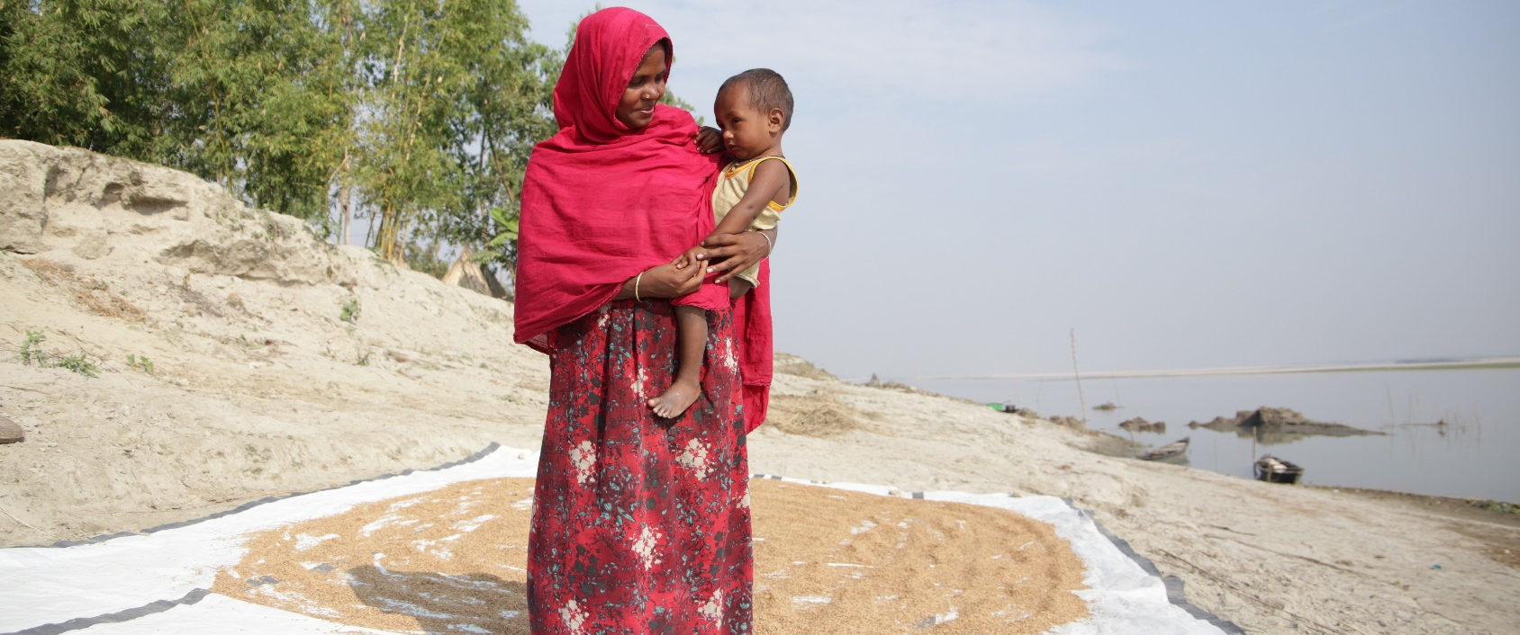

ShelterBox Update
February 2020

FROM THE FIELD: Homes washed away in Bangladesh

Close to the Indian border in the north-west of Bangladesh lies the Brahmaputra river, which snakes through the country and out into the ocean. During the dry season, a large part of the riverbed becomes fertile land for farming. It’s easily accessible for traders, who move up and down the banks, often crossing with their heavy goods on horse and cart. Heavy downpours submerge most of the country, and the fruitful landscape looks like the open sea, only accessible by boat.

During the rainy season in 2019 heavy monsoon rains triggered flooding in the low-lying areas of Bangladesh, leaving around one third of the country under water. While the country is used to flooding caused by the annual monsoon season, continuous rain and flooding in neighbouring Nepal and India has seen an overflow into Bangladesh’s two major river systems. This has caused the water levels to rise to their highest in 100 years.

32-year-old Behula lives with her disabled husband and four children on a small island on the Brahmaptura river. It’s about a 30-minute boat ride from the mainland. In 2019, the community they live in was severely affected by heavy rains, and many people lost their homes.

“The water level was up to my chest. All through the night we cried, I called people, but they couldn’t come easily. In the night people did not come. We moved our cattle to the nearby market and stayed for six days on a boat. We suffered a lot compared to the previous years.”

As well as the community, Behula and her family were supported by ShelterBox and the Bangladesh Red Crescent. Along with more than 700 families, they received a shelter tool kit and tarpaulin to support their recovery. Almost five months after the floods, Behula was still using the materials provided by ShelterBox. “We used the saw to cut the bamboo for our home. We fixed the fences with the nails and the wire. I use the hoe for digging, I also used it to level the ground. I use the tarpaulin to dry grains. Every item was helpful”, she said.

Behula said she is aware that there might be more flooding and is already worried about how bad it will be. “I am much more anxious about the flood next year, here is not the right place to live. We have to move from here to another place, but we don’t have money to buy land where we can move.”

Knowing they cannot move away from the river, Behula said she will continue to make her home stronger to be prepared for potential flooding next year. She concluded by saying: “Everyone hopes for the best. Everyone prays to God for improvement. I hope to live in peace with my husband and my children.”

You can read more about where ShelterBox is working at www.shelterboxcanada.org/operations-update/

--------------------------------------------------------------------------------------------------------------------------

