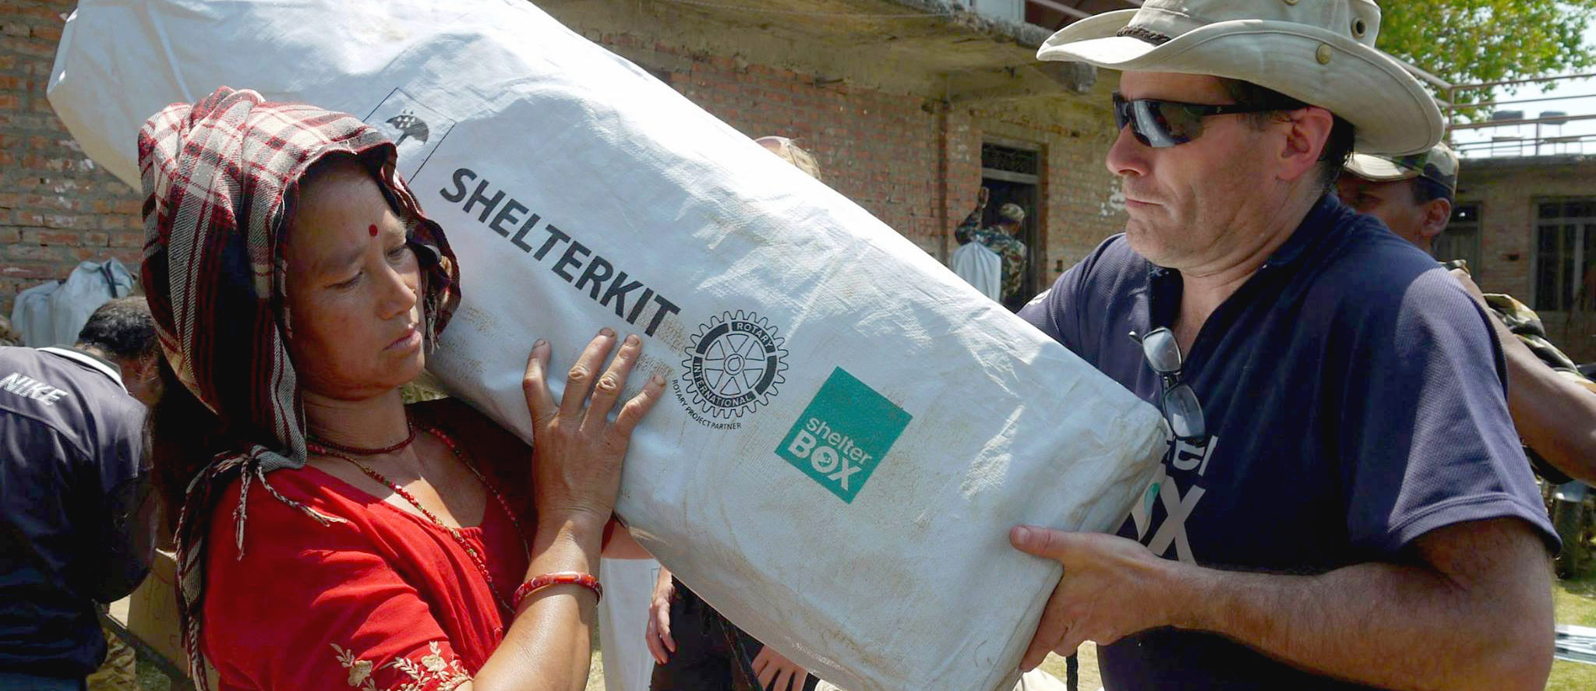20 YEARS OF VOLUNTEERS: Volunteer Spotlight - Rotarian Dave Hallett
ShelterBox Update
April 2020

This year, ShelterBox is celebrating 20 years of disaster relief! In 2000, the idea for ShelterBox was thought up by the Rotary Club of Helston-Lizard in Cornwall, United Kingdom as a project to mark the Millennium. ShelterBox was launched by the club that same year. We have grown to become a respected humanitarian organization and have supported over 1.5 million people. Volunteers are the backbone of everything that we do at ShelterBox. From fundraising to responding to disasters when they strike, we could not reach nearly as many families without the support of our many committed and enthusiastic volunteers.

With National Volunteer Week this month, we are recognizing one of our dedicated volunteers who, without their support, we would not be able to help families on their journey of self-recovery. We would like to introduce you to Rotarian Dave Hallett.

Dave has been volunteering with ShelterBox since 2006 and was fundamental in the creation ShelterBox
Canada in 2010. He began his ShelterBox journey as a Rotarian from the Rotary Club of Kingston Waterfront, raising funds to support families and ShelterBox awareness. In 2007, he accepted the opportunity to be trained to become a ShelterBox Response Team Member. After training, he had the opportunity to deploy in areas that had been hit by many different disasters. His first deployment was to Somaliland in September 2007 in response to a conflict that displaced thousands. After deployment, Dave was even more inspired to spread the word about his experience working in the field with Rotarians all over the country.

“When you are able to hand-deliver shelter to families who have lost their homes, loved ones and livelihood, you know you are helping those families with tangible aid on their journey to recovery.”

After more than 14 years of service, Dave continues to be a ShelterBox Response Team Member (SRT) and ambassador who pours his ShelterBox passion into everything he does. He plans to continue to deploy in regions in need, but also to continue to work to raise awareness around the importance of ShelterBox’s mission so that Rotarians are ready to help when disaster strikes.

“The look of relief on a mother's face when she gets to move her children into a tent or a father's look of determination to repair his family's home when provided a ShelterKit is priceless.”

This April we want to thank Dave and all our amazing volunteers for everything that they do for ShelterBox.
Read more about how you or your club can volunteer with us: shelterboxcanada.org/actiontoolkit

--------------------------------------------------------------------------------------------------------------------------

