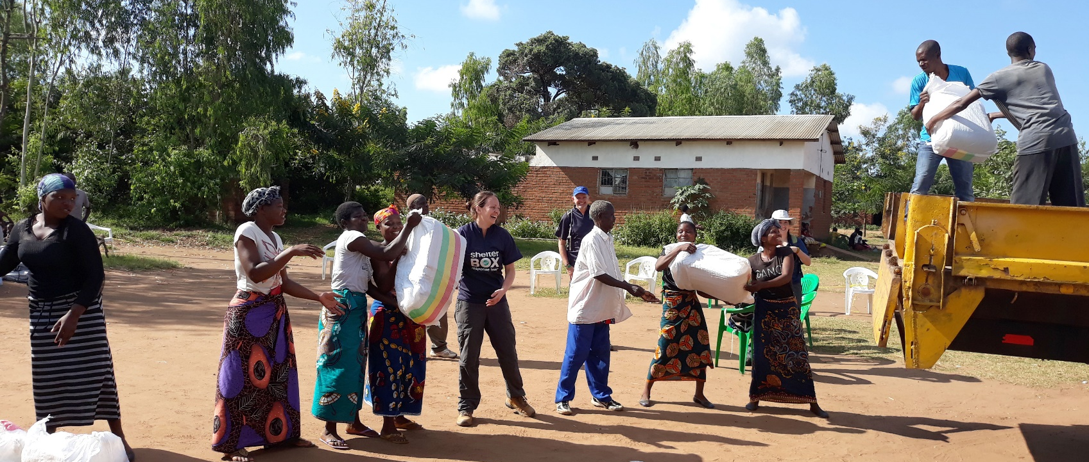
FROM THE FIELD: Rotary in Malawi
ShelterBox Update
June 2019
In early March floods hit Malawi and intensified after Cyclone Idai which brought heavy rains to Southern Africa. This has forced approximately 86,000 Malawians from their homes.

ShelterBox teams provided ShelterKits, water filters, blankets, kitchen sets and mosquito nets to families across Chikwawa and Mulanje regions, supporting 2,000 families. Our ShelterBox Response Teams worked with Rotary throughout our response and received this letter of thanks from Eric, the President RCL/Chairperson of the Disaster Relief Committee in Malawi.

“On behalf of Rotary Club Malawi, it was indeed a great experience to work with ShelterBox.

Partnership is great, we have not only walked a mile in reaching out to the many Malawians who faced hardship, but both ShelterBox and Rotary, we restored confidence in the displaced persons that all was not lost!

I was, as leader of Rotary Disaster Relief Team, more supported by ShelterBox in your early contacts with DODMA (Government Disaster Management Agency) and making available to us the situation analysis and needs assessment reports. Between ShelterBox and Rotary we worked together and agreed on which team had to handle specific assignments. We scored pretty good successes through this understanding of specialization.

I enjoyed the working relationships which ensued with the entire team from ShelterBox. I was kept informed of developments and progress which was being made by SB, which information I in turn shared with Governor Hutch and the Disaster Relief Committee at my end. Great people.” – Eric, President RCL/Chairperson Disaster Relief Committee

Our work in Malawi and around the world would not be possible without the support of Rotarians around the world. You can learn more about this amazing partnership at www.shelterboxcanada.org/rotary

NEW UPDATE: Introducing the Rotary Action Toolkit
Are you looking for resources to support your fundraising and awareness activities for ShelterBox? Check out our new Rotary Action Toolkit.

The toolkit is designed to provide information and tools you need to support the partnership between Rotary and ShelterBox in your communities. Access resources on how to fundraise, volunteer and access our training centre to use resources used by our ShelterBox Response Team members to help with your Club’s communication, goal setting and more. www.shelterboxcanada.org/actiontoolkit

ShelterBox Canada – 159 Jane Street, Office 2, Toronto, ON M6S 3Y8
E: support@shelterboxcanada.org T: 647.352.1930 www.shelterboxcanada.org

ShelterBox and Rotary are official project partners in international disaster relief. ShelterBox is a registered
charity independent of Rotary International and the Rotary Foundation

