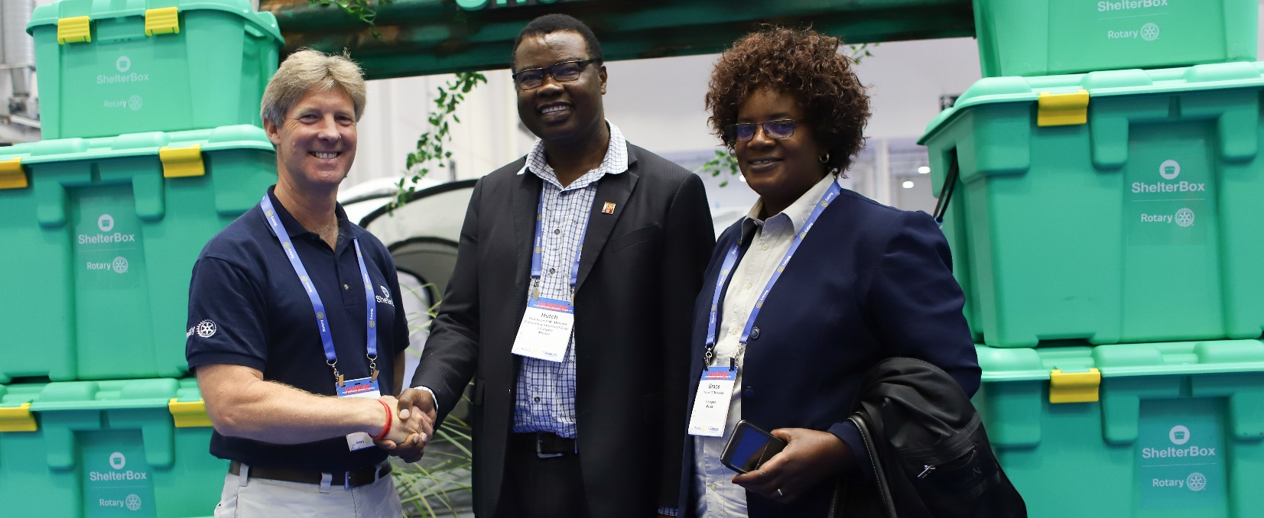
2018-2019 Rotary District 9210 Governor, Hutch Mthinda from the Rotary Club of Lilongwe (pictured middle) stopped by the ShelterBox booth at Convention to say thank you for the ShelterBox response to Cyclone Idai in his District in Malawi
ShelterBox Update
July 2019

PARTNERSHIP: Renewing for 3 years
ShelterBox is celebrating signing up for another 3 years as Rotary International’s Project Partner in disaster relief.

What began as a local connection with one Cornish Rotary Club has led to an international movement that’s raised over $90 million for ShelterBox to date – enough for 140,000 ShelterBox family tents or 390,000 ShelterKits.

First adopted as a millennium project by the Rotary Club of Helston-Lizard in 2000, the support of Rotary members and clubs around the world saw ShelterBox become Rotary’s Project Partner in Disaster Relief in 2012. Since then, the partnership has helped transform ShelterBox into an internationally recognized disaster relief charity, supporting families with emergency shelter after disaster.

The partnership extends far beyond financial support. Around 1,000 Rotary members are involved in ShelterBox as volunteers, staff or response team members. And clubs worldwide offer valuable, practical assistance to help ShelterBox reach more families fleeing disaster or conflict.

Speaking about the partnership renewal, General Secretary of Rotary International John Hewko said:
‘ShelterBox has been Rotary’s Project Partner in Disaster Relief since 2012, and we are excited to renew the partnership for another three years. Through this project partnership, Rotary members around the globe can collaborate with ShelterBox to support communities in desperate need of emergency temporary shelter and vital supplies following natural disasters. Additionally, Rotary and ShelterBox will continue to expand cooperation efforts through preparedness training and stockpiles of prepositioned aide in disaster-prone regions.’

Rotary club presidents around the world have also commented. Ace Robin, President of the Mataram Rotary Club, Indonesia, was caught up in the deadly earthquakes that hit Lombok in 2018. Her home survived, but many around her were destroyed. Through an agreement with the government-led response, Ace’s club was central to bringing ShelterBox aid to Indonesia.

Thanks to their support, vulnerable members of the community received vital emergency shelter, including families with elderly relatives, pregnant women or new mothers. Ace said: ‘Working with ShelterBox taught us a lot – they showed us how to build shelter and select families to help. It also gave us a chance to show what Rotary is to local people.’

We are grateful for the incredible support and acts of partnership shown by Rotarians and Rotary clubs around the world. If you would like to learn more about the partnership or how your club can support ShelterBox Canada, please visit our Action Toolkit at www.shelterboxcanada.org/actiontoolkit

ShelterBox Canada – 159 Jane Street, Office 2, Toronto, ON M6S 3Y8
E: support@shelterboxcanada.org T: 647.352.1930 www.shelterboxcanada.org

ShelterBox and Rotary are official project partners in international disaster relief. ShelterBox is a registered
charity independent of Rotary International and the Rotary Foundation

