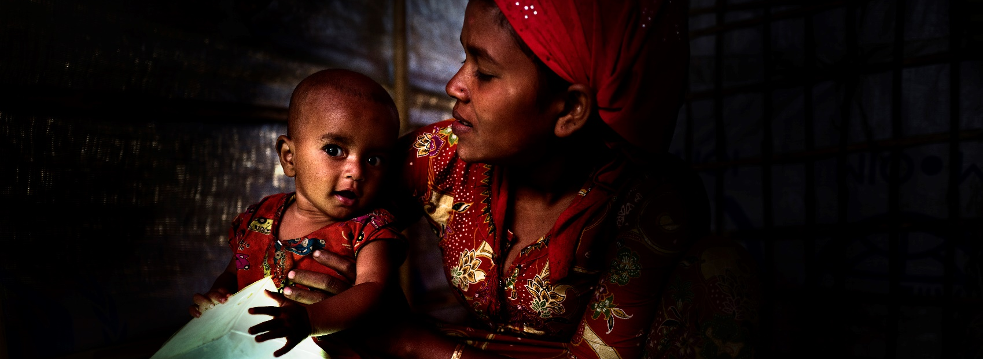

ShelterBox Update
October 2018

SHINE FOR SHELTERBOX: Make a difference this winter
Is your Rotary Club looking for a way to support ShelterBox and engage your local community? Join communities and Rotary Clubs all over the country this winter and get together to brighten lives by hosting a fundraising candlelit dinner for ShelterBox Canada.

Shine for ShelterBox is the perfect way to not only raise funds and awareness about ShelterBox Canada and our partnership with Rotary, but to also introduce your community to the amazing work Rotary does to support disaster relief. Sign up at www.shelterboxcanada.org/shine

“We had a lot of fun on our wine and cheese Shine evening. We invited a Rotary Club member and his wife to talk about their Camino adventure, and presented an overview of ShelterBox. It was a great social for many club members, their partners and friends. Social, Rotary awareness and ‘doing good in the world’ by supporting ShelterBox - What could be better?” – Mike French, Member of the Rotary Club of Calgary West, District 5360 Past District Governor.

TIMELY RECOVERY
With each different disaster, the speed at which we are able to help families back on the road to recovery differs greatly. Each response is dependent on a number of factors such as the type of disaster, accessibility and existing relationships.

On 29th July 2018, a 6.4 magnitude earthquake hit Indonesia. In the following weeks, more earthquakes measuring 6.9, 6.3 and 5.9 magnitude hit, as well as hundreds of aftershocks. The Island of Lombok was most severely affected by the earthquakes.

Due to the enduring support of Rotary District 3410 and PDG Eva Kurniaty, a ShelterBox Response Team was able to deploy quickly to the affected area. The single Rotary club on Lombok worked tirelessly, providing vital assistance with assessments, training, distributions, and planning of logistics. The work is still ongoing, but in partnership with Rotary we aim to have supported the recovery of a total of 600 families.

CURRENT DEPLOYMENT UPDATE
ShelterBox is currently assisting families in the Philippines following Super Typhoon Mangkhut, Indonesia following a serious earthquake in Lombok, Kenya due to flooding and Somaliland due to drought. We are also supporting families in Ethiopia due to conflict and flooding, as well as in Nigeria, Niger, Cameroon and Chad due to the Lake Chad Basin crisis, Iraq and the Syrian Region due to ongoing conflict. You can find the latest updates at www.shelterboxcanada.org/operations-update
ShelterBox Canada – 159 Jane Street, Office 2, Toronto, ON M6S 3Y8
E: support@shelterboxcanada.org T: 647.352.1930 www.shelterboxcanada.org

ShelterBox and Rotary are official project partners in international disaster relief. ShelterBox is a registered charity independent of Rotary International and the Rotary Foundation

