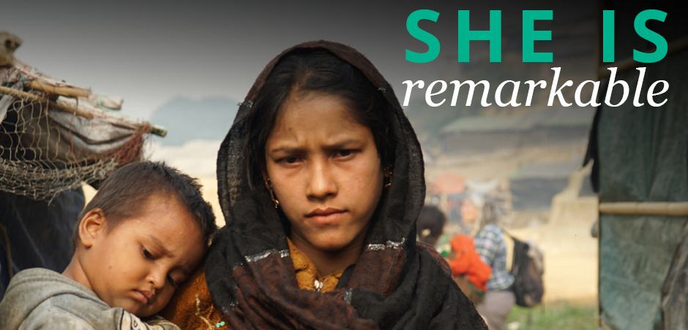

ShelterBox Update
March 2019

INTERNATIONAL WOMEN’S DAY: March 8th
She is strong, she is resilient, she is resourceful. She is every woman displaced by disaster or conflict, and she needs your help. Women and children account for more than 75% of refugees and displaced persons globally. Join ShelterBox and the SHE campaign in empowering women after disaster and conflict.

Higher death rates, increased gender-based violence, maternal death rates, economic loss, and loss of education all adversely affect women in crises. However, women are pivotal in household and community recovery – they are often the first responders to a crisis, and play a central role in the survival and resilience of families and communities.

At ShelterBox, we prioritize the most vulnerable, who are often women, mothers, female heads of households, providing them with essential supplies and training to enable them to rebuild their lives and begin the process of recovery.

This International Women’s day, March 8th, ShelterBox is launching the SHE campaign, reaffirming our commitment to empowering women after disaster and conflict.

Together with Rotary’s commitment to maternal and child health, we can make a difference. We can provide women with essential supplies and training to enable them to rebuild their lives and begin the process of recovery. Together, we can promote resilience of females and female-led households.

CURRENT DEPLOYMENT UPDATE
ShelterBox is currently assessing the need after Tropical Storm Usman made landfall on December 28th in the Philippines. We are also continuing to support families in the Lake Chad Basin following the continued violence in the region. ShelterBox is working with partners in Cameroon, Niger, Chad and Nigeria to support families. ShelterBox is also active in Somaliland due to drought and Indonesia following earthquakes and a tsunami in September. We are also supporting families in Ethiopia due to conflict and flooding, as well as in Iraq and the Syrian Region due to ongoing conflict.

You can find the latest updates at www.shelterboxcanada.org/operations-update
ShelterBox Canada – 159 Jane Street, Office 2, Toronto, ON M6S 3Y8
E: support@shelterboxcanada.org T: 647.352.1930 www.shelterboxcanada.org

ShelterBox and Rotary are official project partners in international disaster relief. ShelterBox is a registered charity independent of Rotary International and the Rotary Foundation

