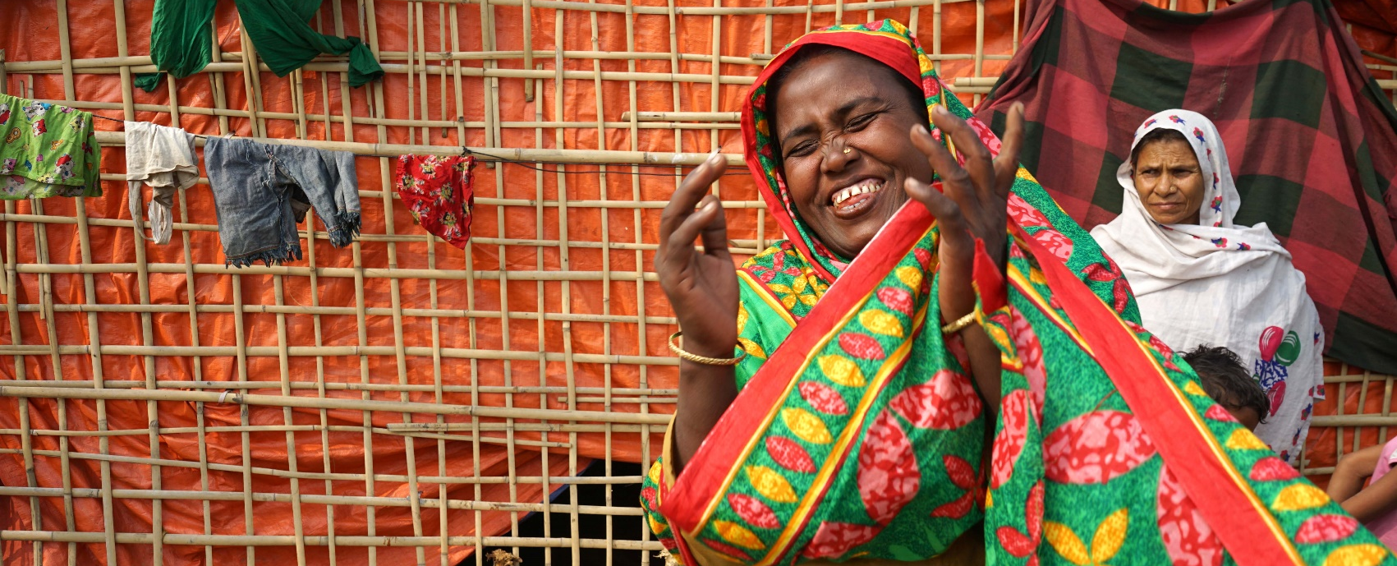

ShelterBox Update
January 2019

Syeda, Bangladesh 2018

SHELTERBOX IN 2018: Year in review
With another end to the calendar year everyone at ShelterBox would like to thank Rotarians across Canada for their continued support of ShelterBox. In 2018, we say another year of unprecedented disasters. From our continued work in the Lake Chad Basin supporting families fleeing violence, to the earthquakes and tsunami in Indonesia. ShelterBox had another busy year, working with local partners and Rotary to hand deliver emergency aid to families in need around the world.
By the end of 2018, with your support ShelterBox provided emergency shelter and essential tools to 210,000 people around the world. We responded to 18 disasters in 17 countries and our amazing ShelterBox Response Team members gave over 1120 days of time to support families who needed our help the most.
We believe that with your continued support in 2019 we can reach even more families next year. Thank you so much for continuing to give your time, support and passion to ShelterBox.
Yours in Rotary,
Tess Widdifield
Rotary and Community Fundraising Manager
The Rotary Club of Toronto Twilight

CURRENT DEPLOYMENT UPDATE
ShelterBox is currently assisting families in Indonesia following a powerful 7.5 magnitude earthquake that struck in September. With the support of our Rotary partners, we are working with the Indonesian Government to help f families in remote villages.

We are also continuing to support families in the Lake Chad Basin following the continued violence in the region. Around 10.7 million people in the Lake Chad region are in need of relief assistance, 2.4 million are estimated to have been displaced and perpetual insecurity continues to drive displacement. ShelterBox is working with partners in Cameroon, Niger, Chad and Nigeria to support families.

ShelterBox is also active in Kenya due to flooding, the Philippines after Super Typhoon Mangkuh hit the country in September and Somaliland due to drought. We are also supporting families in Ethiopia due to conflict and flooding, as well as in Iraq and the Syrian Region due to ongoing conflict.

You can find the latest updates at www.shelterboxcanada.org/operations-update
ShelterBox Canada – 159 Jane Street, Office 2, Toronto, ON M6S 3Y8
E: support@shelterboxcanada.org T: 647.352.1930 www.shelterboxcanada.org

ShelterBox and Rotary are official project partners in international disaster relief. ShelterBox is a registered charity independent of Rotary International and the Rotary Foundation

