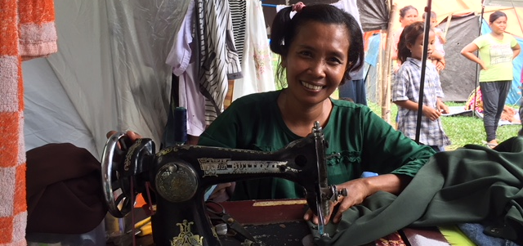

ShelterBox Update
February 2019

Fatnizar, Indonesia 2018

YOUR SUPPORT IN ACTION: New start in Sulawesi
When the earthquake struck Central Sulawesi, Indonesia on September 28^{th,} 2018 it destroyed the home of Fatnizar and her family in Tondo Village, Donggala.

Many of the homes in her neighbourhood survived the earthquake, only to be swept away moments later by the subsequent tsunami. Fatnizar relocated with her husband and four children to a football field five kilometres away. A total of 121 families took refuge on this field across from a school and Fatnizar’s family had to share a space under a large tarpaulin with fifteen other families.

A month had already passed when ShelterBox first discovered this newly formed community. The village leaders identified additional families in the area and with help from the Indonesian Disaster Management Agency and together with our local Rotary partners we were able to assist 150 families with tents, mosquito nets, water filters and carriers.

When we returned the following week on a hot day with light rain falling, Fatnizar was sewing under the awning of her tent. We learned that she had previously worked as a seamstress from her home, creating custom clothing for special orders. When the earthquake took her dwelling it also closed her business. The tent her family had been given not only provided a more private and secure space for the family, but also the opportunity for her to get back to work.

When you as Rotary clubs choose to support ShelterBox, you are providing people with the tools to begin the process of their own recovery. Thank you.

CURRENT DEPLOYMENT UPDATE
ShelterBox is currently assessing the need after Tropical Storm Usman made landfall on December 28th in the Philippines. Teams are assessing the damage and determining whether or not ShelterBox support will be needed.

We are also continuing to support families in the Lake Chad Basin following the continued violence in the region. Around 10.7 million people in the Lake Chad region are in need of relief assistance, 2.4 million are estimated to have been displaced and perpetual insecurity continues to drive displacement. ShelterBox is working with partners in Cameroon, Niger, Chad and Nigeria to support families.

ShelterBox is also active in Kenya due to flooding and Somaliland due to drought. We are also supporting families in Ethiopia due to conflict and flooding, as well as in Iraq and the Syrian Region due to ongoing conflict.

You can find the latest updates at www.shelterboxcanada.org/operations-update
ShelterBox Canada – 159 Jane Street, Office 2, Toronto, ON M6S 3Y8
E: support@shelterboxcanada.org T: 647.352.1930 www.shelterboxcanada.org

ShelterBox and Rotary are official project partners in international disaster relief. ShelterBox is a registered charity independent of Rotary International and the Rotary Foundation

