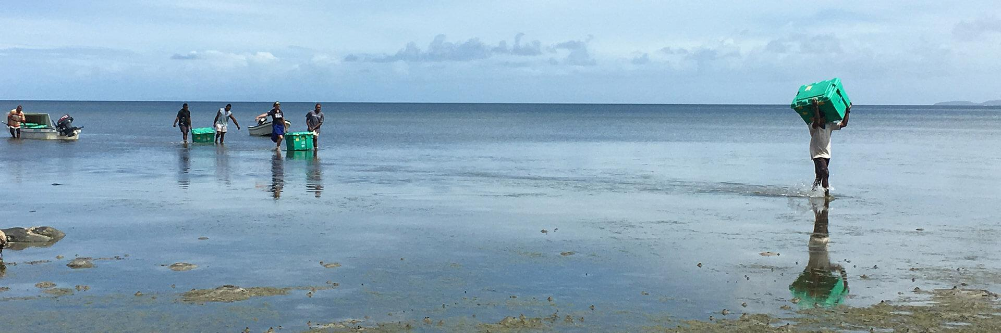

ShelterBox Update
December 2018

ROTARACT 50: Celebrate with ShelterBox
Celebrate Rotaract 50 with your club by raising funds for ShelterBox! Your Rotaract club’s donation of $1,200 or more will help families who have lost everything turn their despair into hope. Join over 150 Rotary and Rotaract clubs in Canada and become a ShelterBox Hero this year!
Challenge 5: Challenge 5 Rotaract clubs in your District to take up the ShelterBox challenge and amplify the difference you make. By working together, you can shelter more families around the world affected by natural disasters and conflict.
Celebrate and Shine: Celebrate Rotaract 50 by bringing light to the lives of families who have lost everything. Host a Shine for ShelterBox dinner and bring your club and sister clubs together to eat, drink, celebrate and raise money for families caught up in disaster.
With every dollar you raise, you’ll be helping to provide solar lights, tents, tools, blankets and pots and pans for families left homeless by disaster.
Celebrate the Rotary Family: Host a community event to celebrate the impact of Rotary and ShelterBox’s partnership around the globe. Invite a ShelterBox Volunteer to share stories from the field and learn how your club can become a ShelterBox supporter or volunteer.
GET CONNECTED: Join the conversation
Did you know that there is a Rotary and ShelterBox Support Group on Facebook? It is a group that brings together Rotarians, ShelterBox Supporters, Staff and ShelterBox Response Teams to discuss all things ShelterBox and Rotary.
It is a great place to see the latest operations updates, Rotary deployment information and video content to share with your Rotary Club. If you would like to join the group and conversation, please search for “Rotary and ShelterBox Support Group” on Facebook and ask to join the conversation!
CURRENT DEPLOYMENT UPDATE
ShelterBox is currently assisting families in the Philippines, Indonesia following the earthquakes and tsunami, Nigeria, Niger, Cameroon and Chad due to the Lake Chad Basin crisis, Kenya due to flooding and Somaliland due to drought. We are also supporting families in Ethiopia due to conflict and flooding, as well as in Iraq and the Syrian Region due to ongoing conflict.

You can find the latest updates at www.shelterboxcanada.org/operations-update
ShelterBox Canada – 159 Jane Street, Office 2, Toronto, ON M6S 3Y8
E: support@shelterboxcanada.org T: 647.352.1930 www.shelterboxcanada.org

ShelterBox and Rotary are official project partners in international disaster relief. ShelterBox is a registered charity independent of Rotary International and the Rotary Foundation

