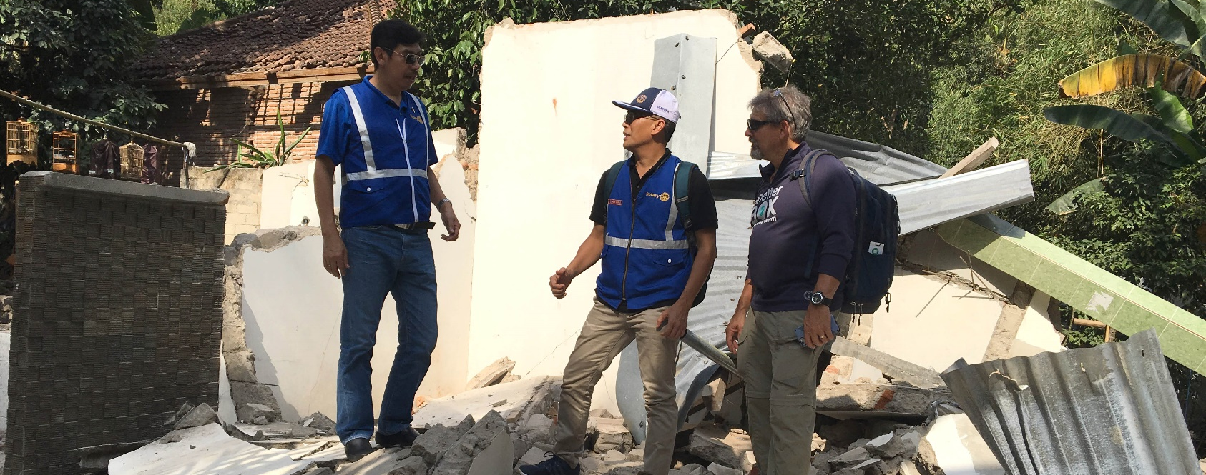

.

ShelterBox Update
September 2018

SHELTERBOX UPDATE: Indonesia Earthquakes

On Sunday, July 29, the island of Lombok in Indonesia was violently struck by a 6.4 magnitude earthquake, leaving at least 17 people dead and hundreds more injured. The disaster was followed by at least 362 recorded aftershocks with a maximum recorded magnitude of 6.2. Over 64,000 homes have been either damaged or completely flattened, leaving families with nothing.
The disaster did not stop there. Less than a week after the initial quake, an even more devastating 6.9 magnitude earthquake hit the island. A total of 18 significant earthquakes have continued to rock the island, spreading terror and panic to local families and tourists. On Sunday 19 August, two more earthquakes measuring 6.9 and 6.3 magnitudes hit the already devastated island. There have been hundreds of aftershocks after the 6.9 magnitude earthquake on the 5th of August.
According to the latest reports, these devastating quakes have killed 460 people and injured over 1000, and have left over 270,000 people without a safe place to call home. These numbers are expected to rise as more tremors are still possible.
We have sent a team of highly-trained volunteers to assess the situation on the ground in Indonesia. The ShelterBox Response Team, made up of volunteer members and Rotarians Liz Odell (UK) and Brian Glenn (USA), have been working with local Rotary contacts and liaising with local authorities to understand whether and how we can help families severely affected by the disaster.
Our team is safe and well. They are currently waiting for aid to arrive via trucks and ferries. They are also working to source tarpaulins locally.
We had aid in the region so we have been able to move quickly, and we are making arrangements with Rotary Lombok and the local government to make sure we can get it to families as soon as possible. You can read more about ShelterBox’s response in Indonesia and read ‘Earthquakes 101’ at www.shelterboxcanada.org/indonesia-earthquake
CURRENT OPERATIONS
ShelterBox is also responding to the ongoing conflict in the Syrian Region and in Iraq, conflict and flooding in Ethiopia, in the Philppines after tropical storms, Kenya due to extreme flooding, the Caribbean after Hurricane Irma and Maria. We are working in Somaliland due to the ongoing drought, and in Cameroon, Chad, Niger and Nigeria due to the ongoing Boko Haram violence.
ShelterBox is constantly monitoring weather patterns and conflict situations around the world and remains ready to respond at a moments notice thanks to the ongoing support of Rotary Clubs and Rotarians around the world. The latest ShelterBox deployment info can be found at www.shelterboxcanada.org/operations-update - Is your club interested in having a ShelterBox presentation? Get in touch at support@shelterboxcanada.org

ShelterBox Canada – 159 Jane Street, Office 2, Toronto, ON M6S 3Y8
E: support@shelterboxcanada.org T: 647.352.1930 www.shelterboxcanada.org

ShelterBox and Rotary are official project partners in international disaster relief. ShelterBox is a registered charity independent of Rotary International and the Rotary Foundation

