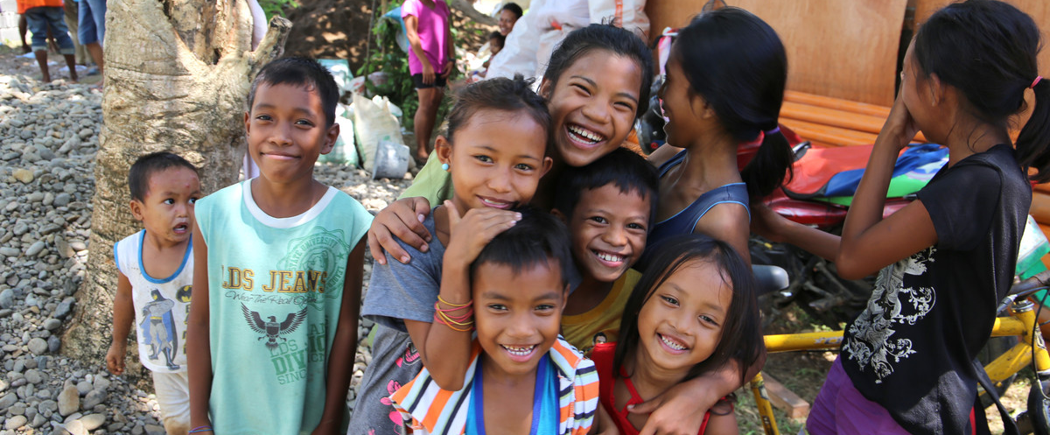

.

ShelterBox Update
July 2018

HAPPY NEW YEAR: 2018-2019 Rotary Year

ShelterBox Canada would like to welcome all Rotarians to a new year with ShelterBox! Over the 2017-18 year, Rotarians and Rotary Clubs donated over $550,000 to help ensure that no family is without shelter after disaster or conflict. We remain incredibly grateful for your continued support to ShelterBox Canada. As you enter this new year with your Rotary Club, we would like to highlight three areas to keep in mind as you plan for the exciting year ahead with ShelterBox.
SHELTERBOX HERO PROGRAM
The ShelterBox Canada Hero program recognizes the ongoing dedication and support of Rotary Clubs in Canada who believe that no family should go without shelter.
Rotary Clubs are recognized based on their total annual giving throughout the year. There are three ShelterBox Canada Hero levels: Bronze ($1,200+), Silver ($3,600) and Gold ($6,000). In appreciation, each ShelterBox Canada Hero will receive a Hero certificate, digital badge for their website and recognition on our webpage. Find the current list of Hero Award winners at shelterboxcanada.org/hero

YOUTH EXCHANGE CHALLENGE
The ShelterBox Youth Exchange Challenge is an exciting opportunity for participants of the program to develop many personal skills all while supporting a Rotary Project Partner and making a real difference to communities around the world.

The challenge is simple. Students are encourage to spread the word about ShelterBox and fundraise for our work around the world in their local community or with their host Rotary Club. Sign up your District by getting in touch with as at support@shelterboxcanada.org

VOLUNTEER WITH SHELTERBOX
With the new Rotary year upon us there are so many ways to be the inspiration and make a difference in our communities and around the world. ShelterBox is looking for more dedicated individual across Canada to join our volunteer team. Whatever skills, knowledge or spare time you have, you can play a vital role in ensuring no family goes without shelter.

Learn more about our various volunteer roles and how you can get involved in the 2019 Rotary year by visiting us at shelterboxcanada.org/volunteer

The latest ShelterBox deployment info can be found at www.shelterboxcanada.org/operations-update
Is your club interested in having a ShelterBox presentation? Get in touch at support@shelterboxcanada.org

ShelterBox Canada – 159 Jane Street, Office 2, Toronto, ON M6S 3Y8
E: support@shelterboxcanada.org T: 647.352.1930 www.shelterboxcanada.org

ShelterBox and Rotary are official project partners in international disaster relief. ShelterBox is a registered charity independent of Rotary International and the Rotary Foundation

