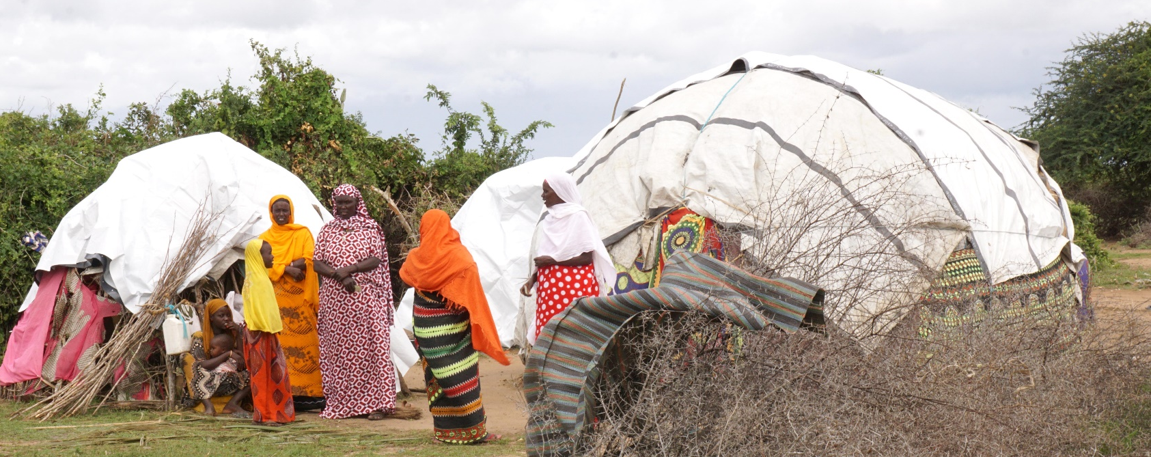

.

ShelterBox Update
August 2018

SHELTERBOX UPDATE: Kenya Flooding

More than 290,000 people have been forced to leave their homes across Kenya, after heavy rains and floodings washed away whole villages.
The devastating flooding was caused by intense downpours in the highlands, swelling the rivers as they made their way towards the sea and bursting the banks. Farmland was covered in a layer of silt. Goats and hens drowned and grazing pasture is now under water. Lives and livelihoods have been hit hard.
We are working with local organizations and Rotary groups to understand how we can help provide emergency shelter to help families start rebuilding their lives. Our teams have visited two different counties in Kenya to understand the problems that families are facing right now.
Families that used to live in Malimo village were forced to leave their homes when the floodwater swept through. The village now shows only a few remnants of habitation – a roof with no walls, a couple of piles of sticks – but no sign of the 104 family homes that were once here. The community are now sheltered under tarpaulins in Kakuyuni Camp, about four kilometres away. We are determined to help as many families as we can, in Kenya and around the world.
SHELTERBOX AND ROTARY IN GUATEMALA: Update from the field
In June, Guatemala was left reeling after the most violent and devastating volcanic eruption in 44 years. The Fuego volcano spewed lava, ash, rocks and deadly hot gas onto hillside villages, killing over 100 people. Hundreds of families are still living in schools and churches. Sanitation and privacy is poor, as these buildings were not designed to house so many people.
We have provided small tents that are being used as safe spaces to give families some privacy and preserve dignity. Our teams have now left Guatemala, but distribution of tents doesn’t end here. We have been working closely with Rotary, who will continue to help families who need it most.
CURRENT OPERATIONS
ShelterBox is also responding to the ongoing conflict in the Syrian Region and in Iraq, conflict and flooding in Ethiopia, in the Philppines after tropical storms, in the Caribbean after Hurricane Irma and Maria. We are working in Somaliland due to the ongoing drought, and in Cameroon, Chad, Niger and Nigeria due to the ongoing Boko Haram violence.
ShelterBox is constantly monitoring weather patterns and conflict situations around the world and remains ready to respond at a moments notice thanks to the ongoing support of Rotary Clubs and Rotarians around the world.
The latest ShelterBox deployment info can be found at www.shelterboxcanada.org/operations-update
Is your club interested in having a ShelterBox presentation? Get in touch at support@shelterboxcanada.org

ShelterBox Canada – 159 Jane Street, Office 2, Toronto, ON M6S 3Y8
E: support@shelterboxcanada.org T: 647.352.1930 www.shelterboxcanada.org

ShelterBox and Rotary are official project partners in international disaster relief. ShelterBox is a registered charity independent of Rotary International and the Rotary Foundation

